The Bridge Problem Name_________________
Here is a side view of a bridge that Diedra drives across as she travels to and from work.
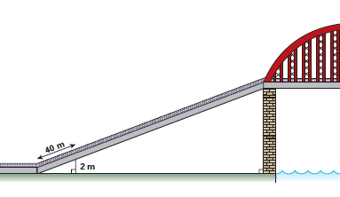

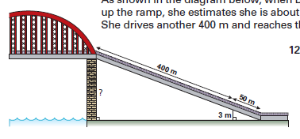
The diagram above shows Diedra’s car 50meters (m) up the ramp, she estimates she is about 3m above ground level. She drives another 400m and reaches the bridge. Richard drives up the other side of the bridge. When Richard’s car is 40m up the ramp, he estimates that he is about 2m above the ground. Both ends of the bridge are the same height.
?

Your Tasks:
- Find two missing side lengths to the bridge pictured above. (Be sure to explain your work)
- Explain how you know the triangles on Diedra’s side are similar
- Identify and explain corresponding sides on the triangles Richard is driving on.

Your Product:
Your product may be in the form of an essay or of a poster. Successful students will create a rough copy on the back of this page before starting their final copy.

Name:
 | 3 | 2 | 1
Missing side lengths | Side lengths are correct with correct math shown. | One side length is correct, however an attempt was made at the other | Attempt made, however no answer or the answer is wrong.
Explanation of side lengths | At least 3 sentences using vocabulary explaining how the side lengths were found. | At least 2 sentences using vocabulary explaining how the side lengths were found. | at least 1 sentence present, however, no vocabulary is used,
Similar triangles explanation | Correct answer with at least 2 mathematic details to support why the triangles are similar | Correct answer with at least 1 mathematic detail to support why the triangles are similar. | Answer given, however it is incorrect.
Corresponding sides explanation | Correct answer with at least 2 mathematic details to support corresponding sides | Correct answer with at least 1 mathematic details to support corresponding sides | Answer given, however it is incorrect.
Total:

